Project Design Phase-II
Data Flow Diagram & User Stories

Date | 26 August 2026
Project Name | Employee Raise Isssue
Maximum Marks | 4 Marks

Data Flow Diagrams:
A Data Flow Diagram (DFD) is a visual representation of how data moves through the Employee Raise Issue System. It shows how employees, HR/Managers, and administrators interact with the system, how issues are processed, and where the information is stored. The DFD represents the flow of data from raising an issue to assigning, tracking, resolving, and closing the issue.

Example: (Simplified)
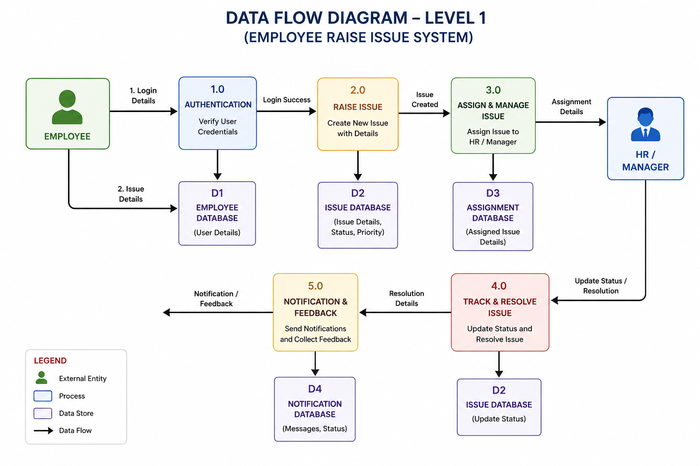

User Stories
Use the below template to list all the user stories for the product.
User Type | Functional  Requirement  (Epic) | User Story  Number | User Story / Task | Acceptance criteria | Priority | Release
Employee | User Registration | USN-1 | As an employee, I can register in the application using my employee details so that I can access the system. | Employee can enter valid details and successfully create an account. | High | Sprint-1
Employee | Login | USN-2 |  | Valid credentials allow login; invalid credentials show an error message. | High | Sprint-1
  As an employee, I can log in using my username/email and password so that I can access my dashboard.
Employee | Raise Issue | USN-3 | As an employee, I can raise an issue by entering the issue title, description and category. | Issue is created successfully and receives a unique Issue ID. | High | Sprint-1
Employee | Issue Tracking | USN-4 |  | Employee can see statuses such as Open, Assigned, In Progress, Resolved and Closed. | High | Sprint-2
  As an employee, I can view the status of my raised issue so that I know its progress.
Employee | Issue History | USN-5 | As an employee, I can view my previous issues and their details. | System displays the employee's issue history with dates and statuses. | Medium | Sprint-2
Employee | Comments | USN-6 | As an employee, I can add comments to my issue to provide additional information. | Comment is saved and visible to the authorized HR/Manager. | Medium | Sprint-2
Employee | Notifications | USN-7 | As an employee, I can receive notifications when my issue status changes. | Employee receives notification when issue is assigned, updated or resolved. | Medium | Sprint-2
Employee | Feedback | USN-8 | As an employee, I can provide feedback after my issue is resolved. | Employee can submit feedback/rating for the resolved issue. | Medium | Sprint-3
HR / Manager | Issue Management | USN-9 | As an HR/Manager, I can view issues raised by employees so that I can take appropriate action. | HR/Manager can view authorized employee issues and their details. | High | Sprint-3
HR / Manager | Assign Issue | USN-10 | As an HR/Manager, I can assign an issue to the appropriate person or department. | Issue can be assigned successfully and assignment is recorded. | High | Sprint-2
HR / Manager | Update Status | USN-11 | As an HR/Manager, I can update the issue status so that employees can track progress. | HR/Manager can change status to Assigned, In Progress, Resolved or Closed. | High | Sprint-2
HR / Manager | Resolve Issue | USN-12 |  | Resolution details are saved and the employee is notified. | High | Sprint-2
  As an HR/Manager, I can provide a resolution and mark an issue as resolved.
HR / Manager | Comments | USN-13 | As an HR/Manager, I can add comments or responses to an employee's issue. | Comment is stored with date, time and user information. | Medium | Sprint-2
HR / Manager | Notifications | USN-14 | As an HR/Manager, I can receive notifications when a new issue is raised. | HR/Manager receives a notification for newly raised issues. | Medium | Sprint-2
Administrator | User Management | USN-15 | As an administrator, I can view and manage employee accounts. | Admin can add, update, activate or deactivate users. | High | Sprint-3
Administrator | Role Management | USN-16 | As an administrator, I can assign roles such as Employee, HR/Manager and Admin. | Users receive access according to their assigned role. | High | Sprint-3
Administrator | Category Management | USN-17 | As an administrator, I can create and manage issue categories. | Admin can add, edit and remove issue categories. | Medium | Sprint-3
Administrator | Reports & Dashboard | USN-18 | As an administrator, I can view reports about raised, pending and resolved issues. | Dashboard displays issue counts by status, category and priority. | Medium | Sprint-3
Administrator | Issue Monitoring | USN-19 | As an administrator, I can monitor all issues in the system. | Admin can search, filter and view issue details and history. | Medium | Sprint-3

